June 17, 2003

Dear Zoning and Planning Committee,

Electrical pollution is a largely unrecognized, but widespread problem which causes human and animal health problems. Electrical pollution is caused by an important change in the way we use electricity today compared to when our electrical grid was designed. The grid was originally designed to be used by linear loads (e.g. incandescent light bulbs, electric stoves, motors). We are now using it to run non-linear time varying loads (e.g. computers, energy efficient lights, strobing lights, variable speed drives, dimmer switches). Non-linear time varying loads produce high frequencies or “dirty” power. Exposure to “dirty” power causes radio wave sickness. “Dirty” power also overloads the neutral wire, which is supposed to return the electricity to the substation. The overloaded neutral causes the “dirty” electrical current to return to the substation via the earth since it is the path of least resistance compared to the overloaded neutral.

Radio and cell phone towers are important contributors to the electrical pollution problem because of the large amount of electronic equipment running at the towers. Various methods outlined by the Institute of Electrical and Electronics Engineers (IEEE) in IEEE Standard 519-1992 would drastically reduce the contribution of the equipment running at these towers to the electrical pollution problem. Although this standard is in effect in Wisconsin, it is not being enforced and therefore most towers are not in compliance. The strobing lights that are increasingly replacing the rotating beacon lights on the towers also contribute substantially to the electrical pollution problem. There is a device called an rf choke that can be installed which virtually eliminates the problem.

Sample waveforms and other documentation follow which illustrate various aspects of the threat posed by non-compliant towers. (1) The “dirty” waveform produced by one laptop computer. A school has many such computers, as well as energy efficient lights and variable speed drives controlling heating and cooling functions. The type of distortion of the sine wave by a cell tower and a school are comparable. (2) Waveforms from a school. The first is prior to any filtering being done. The second is partway through the job of adding filters. The next item is a letter from Angela Olstad outlining the health problems they were experiencing at the Melrose-Mindoro Elementary School prior to filter installation and how their health was affected by the installation of the filters. (3) This waveform was collected from a farm located approximately three miles from the cell tower. The waveform occurred each time the light flashed. The initial impulse is 25 MHz, which is well into the radio frequency range, and is 77 millivolts in amplitude three miles from the light. Reducing exposure to high frequencies has been associated with a gradual improvement in herd health. Improvements have been seen in coat health, temperament (cows were more settled), fewer foot problems (decreased hairy warts, fewer/no abscesses, decreased problems with ski-like hooves), better breeding, lower somatic cell count, and improved milk production. The next item is a graph of milk production vs. transients. Transients are high frequency events. Dr. Hillman et al found that milk production decreased as transient exposure increased. The last item is a proposed motion to require compliance with the IEEE 519-1992 and rf chokes on strobing lights.

These waveforms show that equipment such as that used to run cell and radio towers are a source of high frequencies. The school experience and Dr. Hillman’s research demonstrate that exposure to high frequencies causes health problems for humans and animals.

I hope you will put the motion on your agenda and allow me to attend the meeting to answer questions. The towers are already supposed to be in compliance, so the motion would only serve to enforce rules that are already in place. The savings in terms of healthcare costs and the economic benefit of reducing the handicap dairy farmers are operating under now would far outweigh the costs incurred by the radio and cell tower industry for enforced compliance with the existing standard. For more information about electrical pollution, please visit my website www.electricalpollution.com.

Sincerely,

(1)

This is how much one PC laptop computer distorts the sine wave. The equipment at a cell tower is almost exclusively electronics that distorts the sine wave similarly.
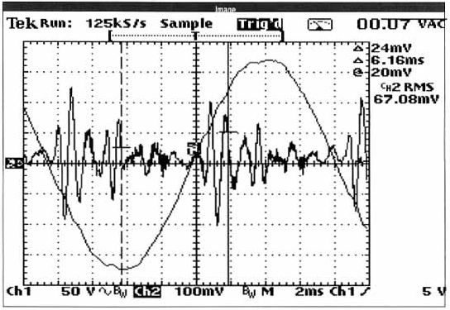
(2)
This waveform was collected in a high school before any measures had been taken to “clean up” their electrical pollution problem. The staff and students were experiencing health problems whose symptoms matched the symptoms of radio wave sickness.
This is a waveform from the same high school after they began to “clean up” the electrical pollution by installing some filters. Notice the difference in the waveforms.

Explainable Health Conditions
Written By: Angela Olstad
Mindoro Fourth Grade Teacher/Building Principal

Many people in the Melrose-Mindoro School District are feeling better because of the recent electrical clean up in our schools. This problem is known as electrical pollution. The staff suffered from unexplainable health conditions for years. The list of symptoms includes: fatigue, memory loss, facial flushing, rashes, headaches, numbness, eye irritation, depression, sleep disturbances, double vision, asthma difficulties, sinus infections, bronchitis, loss of taste and smell. These health conditions began when school started and gradually went away throughout the summer months.

Mr. Dave Stetzer, a power quality manager, was hired to evaluate the electrical condition of our schools. He found many problems in the electrical system. The ubiquitous meter readings should have been zero, but our school had numbers as high as 150+. Dr. Martin Graham a professor from University of California, Berkeley has defined ubiquitous pollution. Dr. Neil Cherry a professor from Lincoln University says a safe level of exposure to RF (radio frequency) is zero. To clean up the electrical pollution the electricians rewired the computer lab and put filters into the many outlets throughout our building. This took a few days and the costs were minimal. Yes, it was that easy. The readings in the building are now averaging 15 or below. An acceptable level could be below 20. The Mindoro Elementary School, for example, is 36 years old. The wiring in those days does not stand up to the demands of today. The demand on electrical wiring is growing rapidly everyday, everywhere.

Mr. Stetzer has also evaluated the electrical condition for Blair-Taylor, Marshfield, Cochrane Fountain City, and Brighten Schools. These schools are now living the benefits from their electrical clean up. Problems were also found in the Spencer School District.

The results are incredible- healthy people! Staff attendance has improved greatly, and students are now being called their right names. Every symptom above is gone or has improved significantly. Once again we enjoy teaching.

The students are also benefiting from the electrical clean up. The school nurse has documented no need for the commonly used asthma nebulizer and inhaler use is down. In addition the attitude and effort of the students has improved.

It is important that if you or others you know are having these same symptoms that you do something about it. Do not let these problems ruin your life. The Melrose-Mindoro School District is very lucky, the school board and superintendent came to us with this information. In order to get the help needed talk to your school administrators about electrical pollution until they listen. Do the research and know the facts.

Yes, electrical companies deny this is happening, but soon they will have to open their eyes and admit there is a problem. People are suffering for no reason. Are you one of those people? Electrical pollution can be cleaned up and help is available, affordable and necessary. Do not let another day go by without doing something to help yourself and those around you. Insist that your schools get checked for electrical pollution so you can start feeling better today. Your health can improve that quickly, ours did.

For further information - DAVE@STETZERELECTRIC.COM -OLSTAD@MEL-MIN.K12.WI.US
- ELECTRICALPOLLUTION.COM - POWERLINEFACTS.COM
(3)
The farm is located approximately 3 miles from the cell tower with the strobing light generating this waveform.

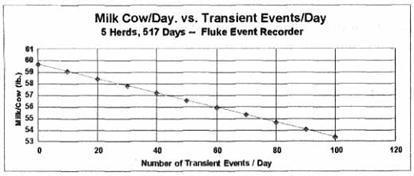
Figure 3. Relationship of Transient Events to Milk Production/Cow/Day, Five Farms, 517 Days. (From a condensed version of “Relationship of Electric Power Quality to Milk Production of Dairy Herds”, Hillman et al.)

Proposed Motion for XXXXX County

I hereby move to create an ordinance requiring that all future cellular towers and towers which provide for radio frequency distribution, as well as, co-location of additional cellular servers or radio frequency distribution service on existing towers within XXXXX County comply with harmonic control in electrical power systems as provided for in the Institute of Electrical and Electronics Engineers Standard (IEEE) 519-1992. Further, all existing and future cellular towers and towers which provide radio frequency distribution which have strobing lights shall be required to install the optional rf choke. Any tower not in compliance with IEEE 519-1992 or without an rf choke on a strobing light at the time of an application for a variance or permit to place a co-located service shall install the rf choke and make those improvements necessary to comply with IEEE 519-1992 before approval by the XXXXX County Zoning and Planning Committee is granted. The applicant shall pay a fee equal to actual costs incurred by the XXXXX County Zoning and Planning Committee to verify compliance with IEEE 519-1992 and the installation of the rf choke by an electrical technician of the County's choosing.

