Public Service Commission of Wisconsin

Ave M. Bie, Chairperson 610 North Whitney Way Joseph P. Mettner, Commissioner P.O. Box 7854 Robert M. Garvin, Commissioner Madison, WI 53707-7854

November 1,2001
Mrs. Catherine Kleiber N9387 Riverview Drive Waterloo, WI 53594
Re: Response to October 8, 2001 Letter
Dear Mrs. Kleiber:
Thank you for your letter of October 8, 2001. You misunderstood the point I was trying to make at the meeting you refer to in that letter. I was referring to an increase in lightning storms in California relative to Wisconsin. Lightning is a tremendous discharge of electrical energy and metallic systems are prone to damage if not properly protected (grounded). The average current in a typical lightning stoke is in the range of 100,000 Amperes. The move to ground every pole in new rural distribution construction in Wisconsin was primarily to lower the level of primary neutral-to-earth voltages. Better lightning protection, with less service outages, is just an added benefit.
I find no statistical data to allege that primary neutrals are overloaded. The conductors that serve customers on distribution feeders are sized such that all the loads, even at peak times, demand a fraction of the maximum current carrying capacity of that wire. In three-phase systems, the neutral carries only the imbalance return current while the main balancing current is carried by the phase wires. Grounding rods carry the current that the physics of their location dictates. This is determined on a case-by-case basis for each ground rod. Their function is not as a conduit for "overload" current. Over 175 load box tests on Wisconsin farms for 7200-Volt and above primary systems gives an average of 68 percent current return on the neutral wire at the point of common coupling.
Your example of kiloWatt-hours (energy) returning through the earth is not based on good engineering practice. It is the electric current that can return through the earth, as it is an integral part of the distribution system. This return current is constrained by physics to generally follow beneath the distribution system wires. This is a 'conservation of energy' effect. The current flows through a three-dimensional structure of varying resistivity.
Telephone: (608) 266-5481 Faxr (608) 266-3957 TTY: (608) 267-1479 Home Page: http://www.psc.state.wi.us E-mail: pscrecs@psc.state.wi.us
Mrs. Catherine Kleiber
Page 2
If you have any more questions or comments, please feel free to contact me.
Sincerely,
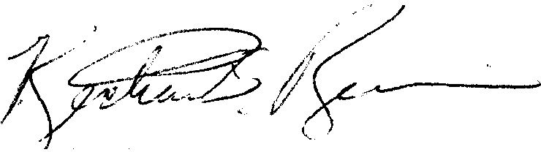
Richard S. Reines
Senior Public Service Engineer
Electric Division
RSR:ljv:L:\svat\DRNZDATA\Kleiber\ltr response 11-01
cc: Senator Scott Fitzgerald
Representative Barbara Gronemus
Representative Jerry Petrowski
Representative David Ward
Ave M. Bie, PSC Chairperson
Secretary James Harsdorf, DATCP
Secretary Phyllis Dube, HFSS
James D. Loock. PSC Chief Engineer
Mark Cook, REPS Program Mgr.
William Fannucchi, PSC Sr. Envir. Plan. Analyst

