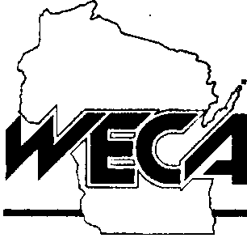
A Division of the Wisconsin Federation of Cooperatives
30 West Mifflin Street, Suite 401?* Madison, Wl 53703 • Phone (608) 258-4400 • FAX (608) 258-4407

January 29, 2002
Senator Scott Fitzgerald Wisconsin State Senate PO Box 7882 Madison, WI 53707-7882
Dear Senator Fitzgerald:
Recently, you co-sponsored a measure authored by Rep. Barb Gronemus, AB 754.
The bill creates an "electric pollution" board, establishes a 1/20 of a cent tax per kilowatt hour of electric power sold in the state, and makes it unlawful for a utility or electric cooperative to permit a condition whereby any steady state electric current flows over its ground conductors for more than five seconds.
I'm writing to convey our serious concerns about this proposal and to provide background information for your consideration.
First, according to our best estimates, the impact on consumers of the 1/20 cent per kWh tax will be $32,000,000 per year (64 billion kwH x 1/20 cent). There are about 2.2 million electric customers in Wisconsin, so the average monthly tax per consumer would be about $1.20 per month per consumer ($32,000,000 /2,200,000/12).
Second, the bill prohibits a utility or cooperative from allowing a condition to exist wherein the utility's ground conductor carries more than zero amps of current for more than five seconds.
The entire point of grounding our electrical system is for purposes of safety. The current has to have some place to go. The bill makes it a serious violation of state law to allow such a condition to exist, even though the electrical systems of most of North America were designed and are operated with ground conductors.
I recognize some electrical "consultants" would like the state's utilities to completely rebuild neutrals, or eliminate grounds, or do other things. However, the preponderance of professional electrical engineering opinion is that such measures are either unwise, unnecessary, unsafe, or all of the above.
Enclosed are three documents I believe may help provide perspective on this issue.
"Call the energy professionals at your electric cooperative today"
First, an editorial from the editor of a Wisconsin agriculture magazine who is a proponent of the "electric pollution" theory. In his editorial he advises people to turn off their outdoor Christmas or holiday lights because they make him sick.
Second, materials circulated by anonymous proponents of Rep. Gronemus' bill on the www.toxicelectricity.com web site. Please note that these supporters are indicating that they are concerned by "radiofrequency sickness." For the most part, electric utilities do not produce radio waves. Radio stations do. Television stations produce waves whose frequencies are between the AM and FM radio spectrum.
Nothing in Rep. Gronemus' bill addresses "radiofrequency sickness."
Finally, enclosed is a recent report of the Wisconsin Professional Dairy Producers Association. The report is an excellent analysis of what—in the opinion of dairy producers themselves—must be done to improve the dairy industry in Wisconsin.
There is no mention of "electric pollution" or any other issue related to electric power or the electrical system.
Our organization has worked hard to sponsor, support, and champion legislation and regulations that benefit the dairy industry. I have dairy farmers on my board of directors. Many of our cooperatives have active dairy producers on their boards or serving as the president of the cooperative. We remain strongly committed to helping this state's dairy industry.
Wisconsin's electric cooperatives will continue to work closely with independent electrical engineers, the REPS program (run by the DATCP and PSC), the U.S. Rural Utilities Service, and the Midwest Rural Energy Council in seeking advice on mitigating or eliminating any genuine power quality problems that may arise on our systems. Moreover, we continue to offer assistance programs for farmers who want to improve the wiring on their farms, and we are continually reexamining our programs to ensure that they meet the needs of our members.
Very sincerely,
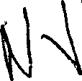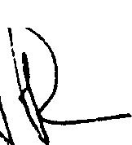

David J. Jenkins WECA Division Manager
Enclosures

